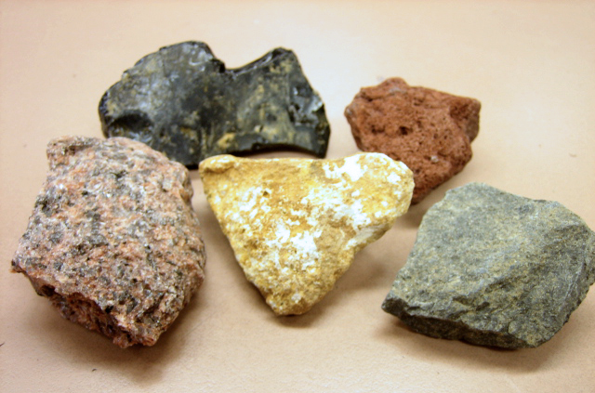

Igneous Rocks

1. You are weathered and eroded, move to **Sediments**.
2. You are heated up and pressurised, move to **Metamorphic Rocks**.
3. You are melted and become **Magma**.
4. You are weathered and eroded, move to **Sediments**.
5. You are heated up and pressurised, move to **Metamorphic Rocks**.
6. You are melted and become **Magma**.

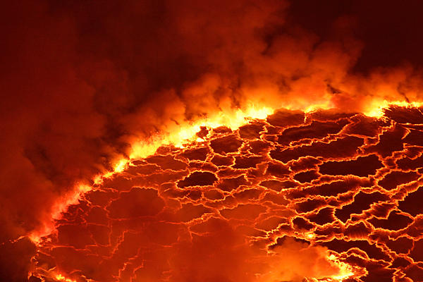

Magma

1. You are erupted from a volcano and solidify, move to **Igneous Rocks**.
2. You remain trapped in the mantle, stay in **Magma**.
3. You are erupted from a volcano and solidify, move to **Igneous Rocks**.
4. You are erupted from a volcano and solidify, move to **Igneous Rocks**.
5. You remain trapped in the mantle, stay in **Magma**.
6. You are erupted from a volcano and solidify, move to **Igneous Rocks**.

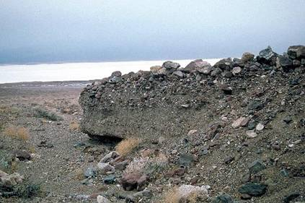

Sediments

1. You are compacted and cemented, move to **Sedimentary Rocks**.
2. You are compacted and cemented, move to **Sedimentary Rocks**.
3. You remain as sediment, stay in **Sediments**.
4. You are compacted and cemented, move to **Sedimentary Rocks**.
5. You remain as sediment, stay in **Sediments**.
6. You are compacted and cemented, move to **Sedimentary Rocks**.

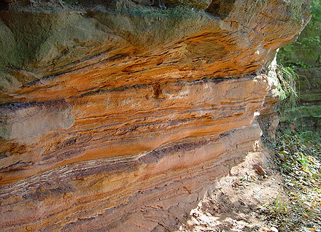

Sedimentary Rocks

1. You are weathered and eroded, move to **Sediments**.
2. You are heated up and pressurised, move to **Metamorphic Rocks**.
3. You are melted and become **Magma**.
4. You are weathered and eroded, move to **Sediments**.
5. You are heated up and pressurised, move to **Metamorphic Rocks**.
6. You are melted and become **Magma**.

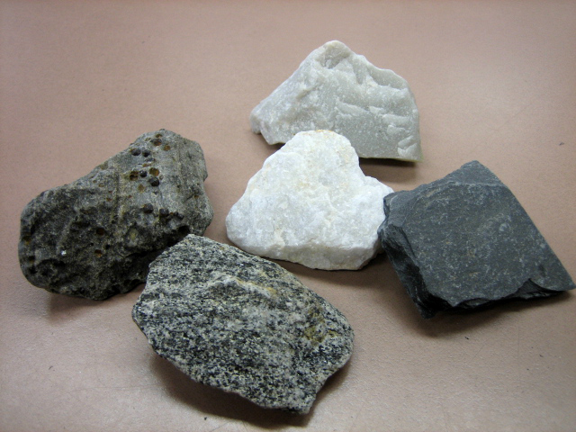

Metamorphic Rocks

1. You are weathered and eroded, move to **Sediments**.
2. You are heated up and melt, move to **Magma**.
3. You are weathered and eroded, move to **Sediments**.
4. You are heated up and melt, move to **Magma**.
5. You are weathered and eroded, move to **Sediments**.
6. You are heated up and melt, move to **Magma**.